Cassidy Bolt

Interactive Graphics

Professor Kenney

20 January 2018

Blog Post #1: Artwork Reflection

**Piece #1:** [Network D (Image 1, 2012), Casey Reas](Network%20D%20(Image%201,%202012),%20Casey%20Reas)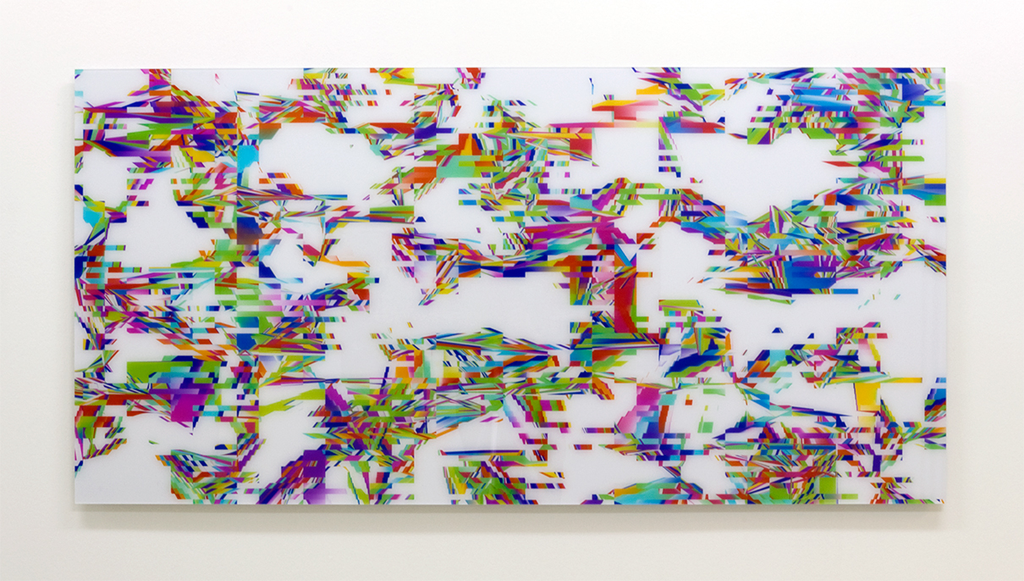

On the first day of class, I immediately was drawn to the work of Casey Reas. Because my mother does graphic design for magazines, I had a rather preconceived notion that digitized graphics were more so functional in nature. However, this piece in particular demonstrates the complex intricacies that can characterize the aesthetic expression of code. I find this work quite interesting because there are portions that seem to have some sort of pattern but at the same time appear in disarray. As a static display in an exhibit, I would not think that there are many expectations for users who interact with this piece. However, I admire the versatility in Reas’ work, which is why I chose to reflect on one of his other mediums as well.

**Piece #2**: [Process 20 (Software 2, 2014), Casey Reas](Process%2020%20(Software%202),%202014)

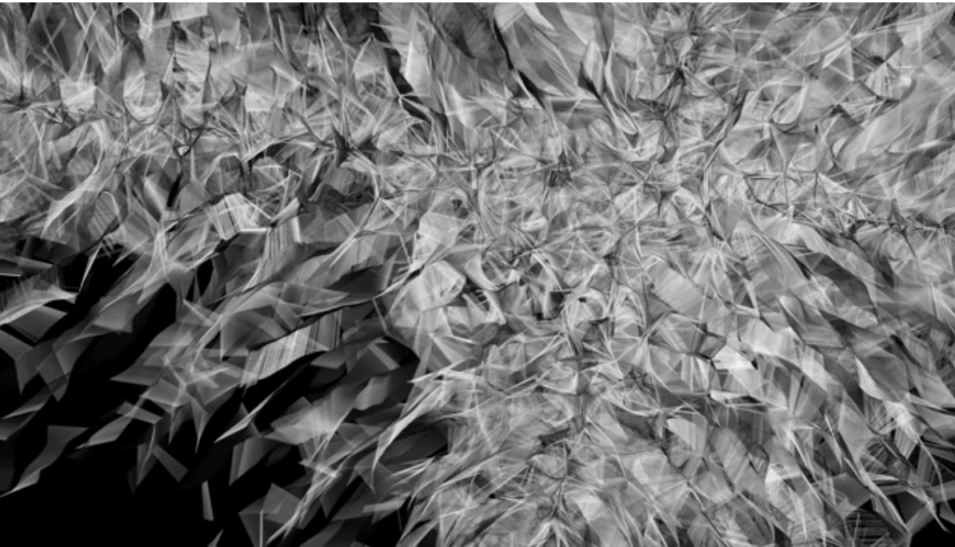

In contrast to Network D, this work takes the form of a video and is an incredibly compelling user experience. I see it almost as the unraveling of DNA or the rise of smoke as a fire burns. The user is expected to watch the sequence and observe the movement of the graphics. I found this piece quite unique, for when I think of visual art, I often forget about the application of movement. Ultimately, I feel quite inspired by the diverse collection that Reas has created and hope to soon be creating such original aesthetic expressions myself.